Web Design

JBS Photo Website

Bernd Weber – x16136781

John Frazer – x16138015

Said Abdulrahman – x16136454

TAble of  
Contents

Website Overview 1

Wire Frames 2

Main page 2

Features 2

Lenses 3

Production Details 4

Requirements Implementation 4

Noteworthy HTML/CSS/JavaScript implementation 4

Validation Errors and Fixes 5

Third Party Tools & Resources 5

Website Deployment Details 6

Team Report 7

How Work Was Split 7

How well you worked as a team 7

Website Validation 8

CSS 8

Web Pages 8

## Website Overview

The website was build based on requirements to have a website which is mainly used for promoting a camera that can be used by beginners as well as by ambitious amateurs and even semi-professional photographers.

The site is meant to provide an overview, some specs, accessories, e.g. lenses, tripods, straps, a camera review and a picture gallery, all embedded in a general photography scheme.

The main (Home) page was made as an entry point only, a few pictures, a few words and the main menu in order to broadcast a clear message what the site is about.

The “Features” page provide some features of the camera of choice (Nikon D610) which was chosen by a team member and amateur photographer. We just provide some main features and then link to the manufacturer’s product spec (Nikon is a registered trademark of Nikon Corporation).

The “User Review” provides a short review, written by photographer Bernd Weber and contains an overview of the camera but also outlines aspects which need attention.

Some lenses accessories are found under “Accessories”, each with a short info.

The “Picture Gallery” shows sample pictures about different genres.

Finally, a contact form allows you to contact us.

## Wire Frames

### Main page

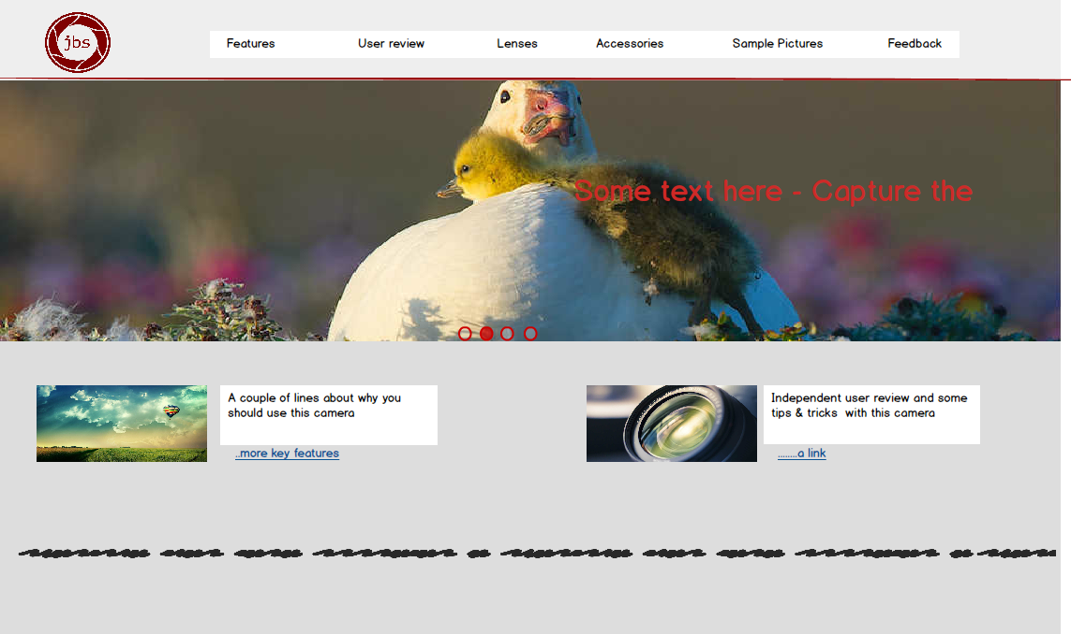

### Features

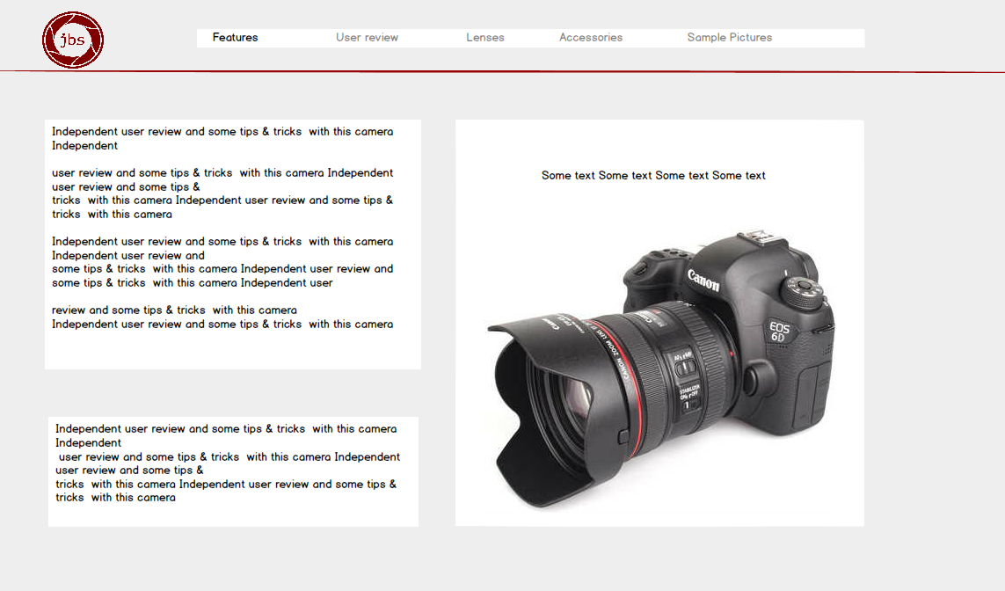

### Lenses

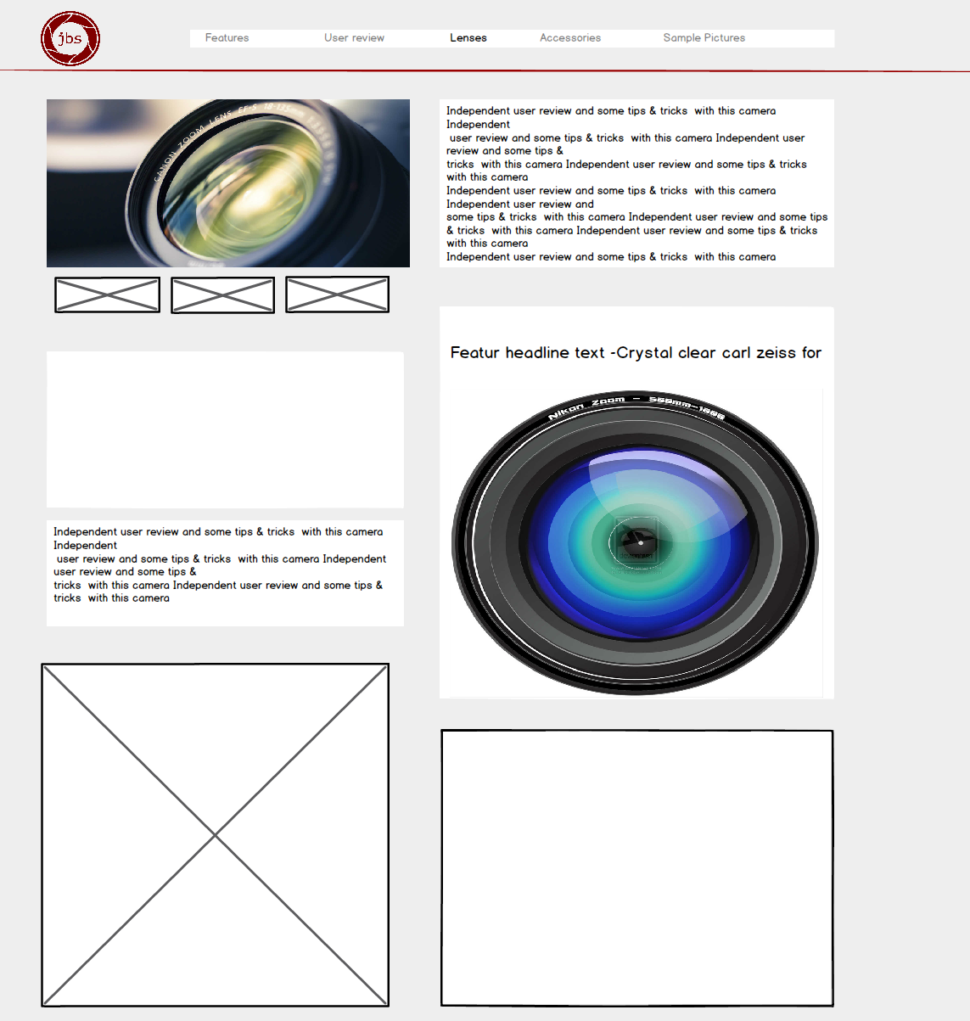

## Production Details

### Requirements Implementation

Taking the given requirements, we went back to a brainstorming to find the right topic for the site. Once the product – the subject – of the site was clear we started to define the number of pages that we wanted to have as well as general aspects, e.g. keep the site clean and clear, how did we want to look the site on every page (kind of a “corporate design” with the option to define the colours and other visual elements at later stage (when we saw that the idea and the structure worked out.

The next step was to create the wireframe to define the structure for the site. Once this was done, the coding started, together with the collection of information and pictures.

### Noteworthy HTML/CSS/JavaScript implementation

#### Skeleton CSS - http://getskeleton.com/

Skeleton is a light-weight, responsive CSS framework. It provides a 12-column grid which is used for layout on the site.

#### Home Page Hero Image Slideshow

TODO To get started right away, just tap any placeholder text (such as this) and start typing.

#### Galleria - https://galleria.io/

The Sample Photos page uses the JavaScript Galleria framework. This is a simple framework which requires the code be downloaded and included with the website, and then included in the <head> of the page. It is also necessary to import jQuery to the page.

Then, there needs to be some simple JavaScript on the page to load and run the gallery. This will display all img elements in “galleria” div.

#### Responsive Main Menu

Inspired by W3Schools - https://www.w3schools.com/howto/howto_js_topnav_responsive.asp

A simple responsive menu which collapses the items into a drop-down menu when the webpage shrinks small enough.

### Validation Errors and Fixes

We are being presented with the following CSS validation error. This error is reported against skeleton.css, which is a third party CSS tool that we are using for responsive design, and cannot change.



### Third Party Tools & Resources

Skeleton CSS - <http://getskeleton.com/>

Galleria - <https://galleria.io/>

W3Schools - <https://www.w3schools.com/howto/howto_js_topnav_responsive.asp>

## Website Deployment Details

Website was built using GitHub for source control. As the website consists of mainly simple pages and client side JavaScript, we also decided to deploy the page on GitHub.

We felt that using GearHost or some other similar service to be overkill. There were also some issues in accessing sites deployed on GearHost from the IBM network, and this would have caused problems with the demo.

## Team Report

### How Work Was Split

TODO who did what

### How well you worked as a team

TODO To get started right away, just tap any placeholder text (such as this) and start typing.

## Website Validation

### CSS

We are being presented with the following CSS validation error. This error is reported against skeleton.css, which is a third party CSS tool that we are using for responsive design, and cannot change.



### Web Pages

#### Home

#### Features

#### User Review

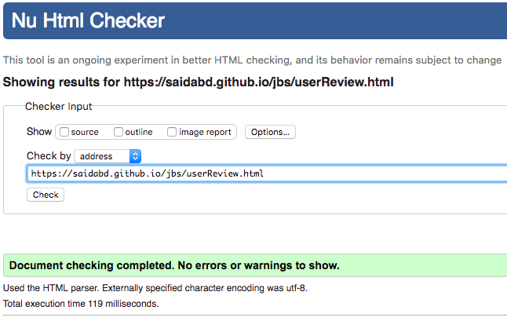

#### Accessories

#### Sample Pictures

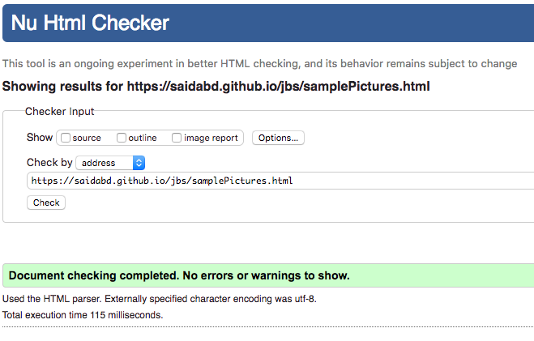

#### Contact

